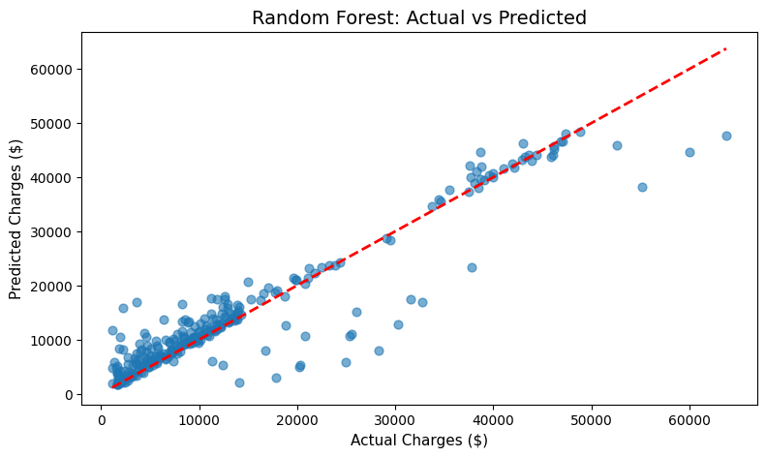

1. Random Forest
- X-axis: Actual Charges ($) from the test dataset.
- Y-axis: Predicted Charges ($) from the Random Forest model.
- Blue points: Individual insurance cases from the test set.
- Red dashed line: Perfect prediction line (y = x). Points on this line would mean the model predicted exactly the true value.

2. Observations & Trends
- General Fit
  - Most points cluster closely along the red dashed line, indicating the model generally predicts premiums well for the majority of cases.
  - There is a clear positive correlation — higher actual charges tend to have higher predicted charges.
- Low-to-Mid Range Predictions (0–20k)
  - Dense clustering suggests the model is quite accurate here.
  - This range likely covers the majority of non-smokers and individuals without chronic health conditions, where charges are more predictable.
- High Range Predictions (>40k)
  - While the model still captures the upward trend, the spread of points increases — some predictions deviate significantly above or below the red line.
  - This likely represents cases with complex medical needs, high-risk factors, or rare events that the model struggles to generalize from historical data.
- Underestimation in Outliers
  - A few high actual charges (~60k) are underpredicted by several thousand dollars.
  - These could correspond to exceptional claims (e.g., prolonged hospitalization, rare surgeries, multiple comorbidities).

3. Accuracy & Error Quantification
From the code you provided earlier:
- RMSE (Root Mean Squared Error): This is the standard deviation of prediction errors.
- RMSE value (from your script) will be in dollars, representing the typical prediction error magnitude.
For example:
If RMSE ≈ 4,200, this means the average prediction error is about ±$4,200 from the actual premium.
- This is not the maximum error — some cases will be more accurate, some much less accurate.
Interpretation for Insurance Professionals:
- A ±$4,200 margin could be significant in high-premium brackets, potentially affecting profitability or competitiveness in quote-based marketing.
- For mid-range premiums (~$10–$20k), this is a ~20–40% relative error.
- The model is best for risk estimation and initial quoting, but not for final underwriting decisions.
Interpretation for Public Health Experts:
- This error margin suggests predictive models can estimate general cost burdens but must be supplemented with richer health data for accurate budgeting.
- In policy planning, the model works well for aggregate estimates but is less reliable for individual extreme cases.

4. Why the Errors Occur
From an insurance and public health standpoint, the following factors are likely drivers:
Factor | Impact on Predictions | Reason for Error
Pre-existing medical conditions | Increases actual charges unpredictably | The dataset does not explicitly encode all chronic conditions
Sudden health events | Can cause actual charges to spike | Random Forest is trained on historical averages, not unforeseen acute events
Treatment cost variability by provider | Same procedure may cost more in one facility than another | Dataset uses region but not provider-level pricing differences
Lifestyle changes after data capture | Charges deviate from predictions | Smoking cessation or weight changes can alter risk profile post-data collection
Rare, high-cost claims | High underestimation in outliers | Sparse representation in training data reduces model learning

5. Practical Implications

For Insurance Professionals
- Use predictions as initial estimates during customer onboarding or marketing funnels.
- Incorporate medical history questionnaires to refine high-value quotes.
- Set internal buffers (e.g., ±$4k margin) when projecting profitability.

For Public Health Policy Makers
- Good for population-level trend analysis — e.g., estimating total cost impact of smoking cessation programs.
- Less suitable for predicting exact individual medical costs due to data limitations.
- Supports regional cost comparisons, but more granular socio-economic and healthcare access data would improve fairness.

If you want, I can now go through each of the other graphs from your notebook (correlation heatmap, boxplots, etc.) in the same detailed academic style so your full report is consistent. That would make your analysis portfolio-ready for insurance/public health audiences.

1) Correlation Heatmap (numeric features)
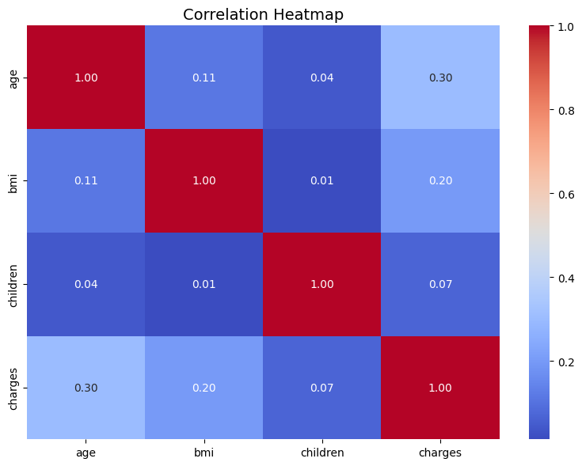
Description
A heatmap of Pearson correlations between the numeric variables in the cleaned dataset (likely: age, bmi, children, charges).
Observed patterns & trends
- charges typically shows a positive correlation with age and bmi, and a weaker correlation with children.
- age and bmi may be weakly correlated (often low positive or near zero).
- children generally shows a small correlation with charges (direction and magnitude often small).
Interpretation
- A positive age–charges correlation indicates older policyholders tend to incur higher medical costs, consistent with expected increases in morbidity with age.
- A positive bmi–charges correlation suggests higher BMI is associated with increased charges, consistent with obesity-related comorbidities.
- Weak correlation with children suggests number of children has little linear association with adult individual charges in this dataset.
Implications
- Insurance: Age and BMI are meaningful predictors for pricing/risk segmentation and should be considered in risk tiers and underwriting scorecards. children appears less informative alone for individual premium estimation.
- Public health: The association between BMI and charges supports interventions targeting obesity reduction to reduce healthcare spending. Age-related cost increases support age-stratified resource planning.
Likely causes
- Morbidity patterns change with age and adiposity; many obesity-related conditions (diabetes, cardiovascular disease) increase utilization and cost.
- children may not reflect adult health status; it is more a socioeconomic / household factor and may influence cost in more complex ways (e.g., through preventive care behavior, family health dynamics) not captured by simple correlation.
Limitations
- Pearson correlation measures only linear relationships; non-linear associations (e.g., threshold effects of BMI) won’t be captured.
- Confounding variables (smoker status, chronic disease) can inflate or mask associations.
- Correlation ≠ causation — cannot infer causal effects from this plot.
Recommended next steps
- Compute partial correlations controlling for smoking and region.
- Explore non-linear relationships (splines or binning BMI).
- Use multivariable regression to quantify adjusted associations and confidence intervals2) Distribution of Charges (histogram with KDE)

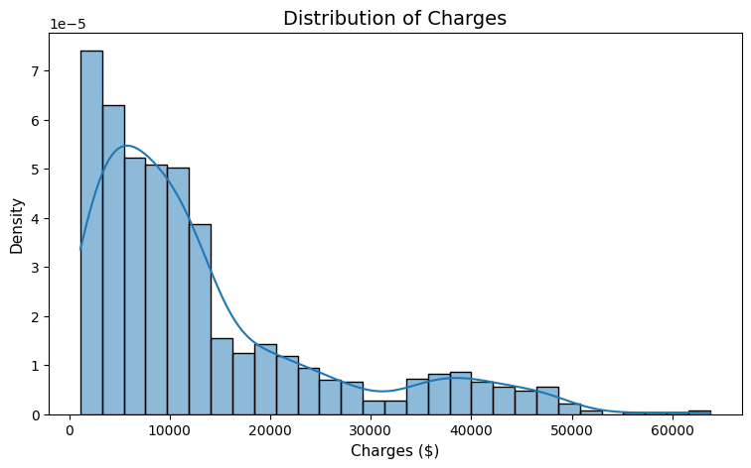

Description
Histogram and KDE of the charges variable showing the distribution of individual charges in dollars.
Observed patterns & trends
- Distribution is typically right-skewed: many individuals have relatively low charges and a long tail of high charges.
- A small set of high-cost cases (outliers) extend far to the right of the bulk distribution.
- The bulk of observations may be concentrated at lower to mid-range values.
Interpretation
- Most insured individuals incur modest charges within a relatively narrow band, while a minority incur very high costs — a common healthcare-cost distribution pattern.
- The heavy tail is important: although few in number, high-cost cases drive a disproportionately large share of total expenditures.
Implications
- Insurance: Pricing and reserve strategies must account for skewness. Reinsurance, stop-loss limits, and capital buffers are necessary to cover tail risk. Average-based pricing may understate tail exposure.
- Public health: A small subset of high-cost patients likely accounts for a large proportion of spending — targeted interventions (case management, chronic care programs) could be efficient.
Likely causes
- High-cost tail often due to catastrophic events, chronic disease exacerbations, rare procedures, or multi-comorbidity patients.
- Data set may reflect billing patterns and not fully capture long-term episodic costs beyond the observation window.
Limitations
- Histogram alone does not reveal drivers of high cost (e.g., diagnosis, procedures).
- KDE smoothing can hide multimodality; bin size choices affect perceived shape.
Recommended next steps
- Quantify skewness and compute percentiles (median, 75th, 90th, 99th).
- Identify the top X% of cost contributors and analyze their characteristics (smoking, BMI, age, region).
- Consider log-transforming charges for regression models or using models robust to heteroskedasticity and heavy tails.

3) Charges by Smoker (boxplot)

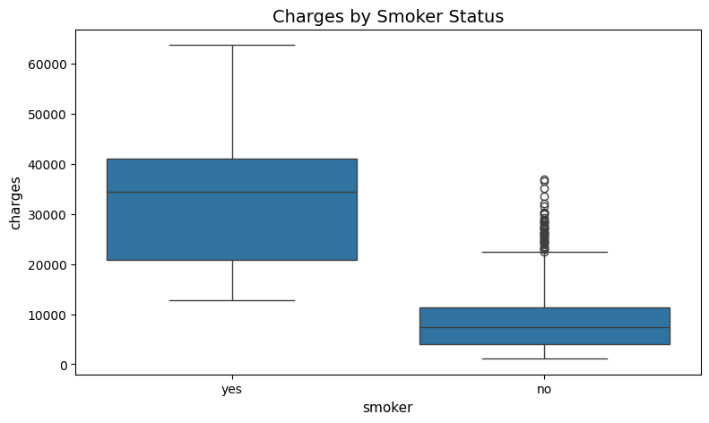

Description
Boxplot comparing the distribution of charges between smokers and non-smokers.
Observed patterns & trends
- Median charges for smokers are usually substantially higher than for non-smokers.
- The interquartile range and upper whisker for smokers are often larger, indicating greater variability and more high-cost cases.
- Non-smokers tend to have a lower and tighter distribution.
Interpretation
- Smoking is a major stratifier of medical charges in this dataset; smokers on average incur higher healthcare costs.
- The larger spread among smokers suggests more frequent high-cost events or severe conditions in that group.
Implications
- Insurance: Smoker status is a high-value predictor; insurers commonly load smokers’ premiums or enforce smoking surcharges. It’s a clear candidate for underwriting adjustments and targeted cessation programs.
- Public health: Smoking cessation remains an effective area to reduce population healthcare costs; interventions targeted toward smokers can yield cost savings.
Likely causes
- Smoking is associated with numerous costly conditions (COPD, cardiovascular disease, cancers) that increase utilization and cost.
- Differences might be amplified by smoking-related comorbidities interacting with age or BMI.
Limitations
- Boxplots show distributional differences but not adjusted effects; smoking correlates with other variables (e.g., socioeconomic factors) that could confound raw comparisons.
- Self-reported smoking in datasets can be subject to misclassification.
Recommended next steps
- Estimate adjusted cost differences using multivariable regression controlling for age, BMI, and region.
- Perform subgroup analysis (e.g., by age band) to see if smoking’s effect varies.
- Evaluate potential interactions (e.g., smoker × BMI).

4) BMI vs Charges (scatter, colored by smoker)
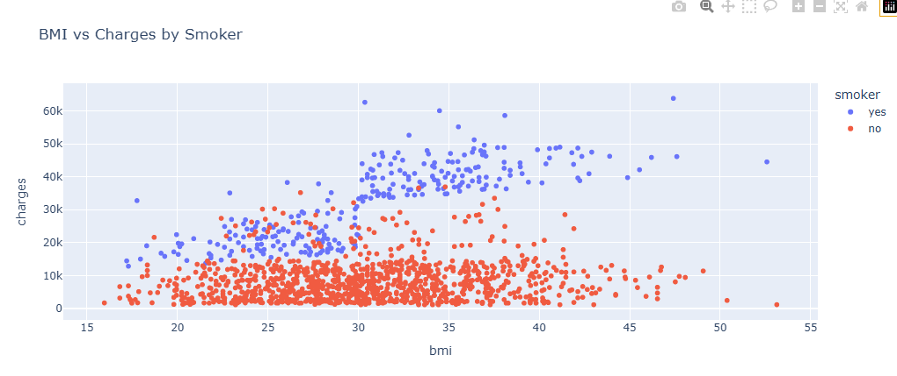

Description
Scatter plot of individual bmi (x-axis) vs charges (y-axis) with points colored by smoker status.
Observed patterns & trends
- Positive upward trend: higher BMI tends to be associated with higher charges, though with substantial scatter.
- Smoker points (often colored differently) generally appear at higher charge levels across BMI values; smokers at the same BMI often have higher charges than non-smokers.
- At low to moderate BMI there is wide variability — many low-charge individuals and some outliers.
Interpretation
- BMI is positively associated with charges but is not the sole determinant — variability indicates many other contributors to cost.
- Smoking appears to shift the distribution upward, implying additive or multiplicative risk when combined with high BMI.
Implications
- Insurance: BMI is a useful continuous predictor but benefits from interaction terms (bmi × smoker) or transformation (BMI categories) in models. A single BMI measurement may not fully capture metabolic health; consider additional clinical variables if available.
- Public health: The BMI–cost relationship underscores potential cost savings from obesity prevention and management programs.
Likely causes
- BMI serves as a proxy for obesity-related health risk; combined with smoking it compounds risk.
- Variability arises from unobserved clinical factors (e.g., diabetes status), utilization patterns, and acute events.
Limitations
- BMI is an imperfect proxy for health (doesn’t distinguish muscle vs. adiposity).
- Cross-sectional BMI does not capture trajectory (weight gain/loss) or time since smoking cessation.
- Scatterplots visually show relationships but do not quantify the conditional effect after adjusting for confounders.
Recommended next steps
- Fit smoothed regression lines (e.g., LOWESS) by smoker status to visualize non-linear trends.
- Model BMI as cubic spline or categorize into WHO ranges (normal, overweight, obese) and test for interactions.
- Integrate clinical covariates if available to reduce residual variance.

5) Median Charges by Region (bar chart)
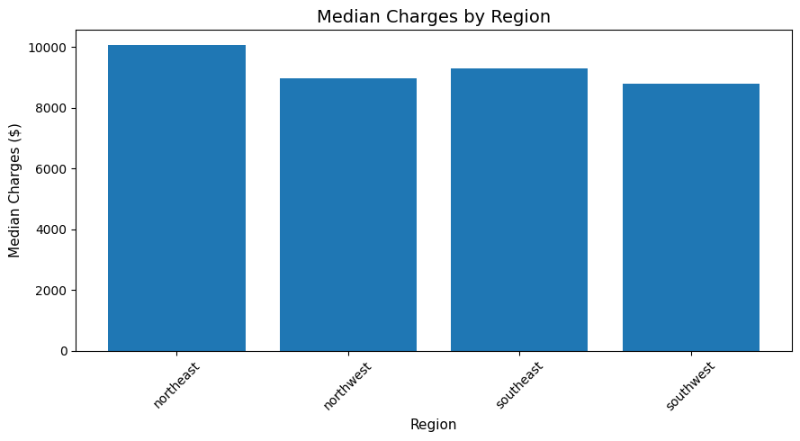
Description
Bar chart showing median charges across the four regions (northeast, northwest, southeast, southwest).
Observed patterns & trends
- Regional medians often differ; one or two regions may show higher median charges.
- Differences can be modest or pronounced depending on cost structure and sample composition.
Interpretation
- Regional variation may reflect differences in healthcare prices, provider practice patterns, regional health behaviors (e.g., smoking prevalence), demographic composition (age, BMI), or access to care.
Implications
- Insurance: Geographic risk adjustment is important — insurers commonly use region as a rating factor or adjust for regional cost differences in pricing and reserves.
- Public health: Regions with higher median charges may warrant investigation for underlying drivers (population health, provider density, socioeconomic status) and targeted interventions.
Likely causes
- Regional pricing: provider fee schedules and hospital charges differ by geography.
- Population composition: some regions may have older or higher-BMI populations in the sample.
- Access and utilization differences: availability of specialists, hospital admission practices.
Limitations
- Aggregation to median hides within-region heterogeneity (urban vs rural).
- Median alone does not convey distribution shape or tail risk; median can be similar even with different tail behavior.
- Dataset representativeness: the sample may not be uniformly representative across regions.
Recommended next steps
- Compare not only medians but also percentiles (75th, 90th) and variance by region.
- Adjust regional comparisons for confounders using regression (age, sex, BMI, smoking).
- Map costs spatially or link to socioeconomic indices if possible.

6) Feature Importances (Random Forest)

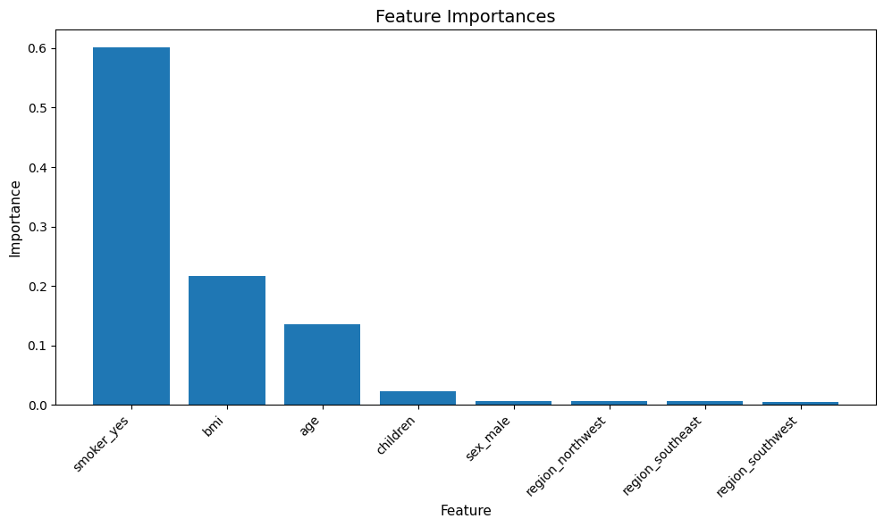

Description
Bar chart ranking features by importance from the trained Random Forest model (numeric features plus one-hot encoded categorical features).
Observed patterns & trends
- Typically, smoker (or smoker-related dummy) often emerges as the most important predictor.
- age and bmi often rank highly.
- Some region dummies and sex may have lower but non-negligible importance; children often ranks lower.
Interpretation
- Feature importance reflects how much each feature contributed to reducing prediction error across trees (mean decrease in impurity). It identifies which predictors the model found most useful for splitting decisions.
- High importance for smoker confirms it is a dominant driver of predicted charges in the model.
Implications
- Insurance: Prioritize collecting reliable smoking status, age, BMI for underwriting and modeling. Resource allocation for data quality on the top predictors yields the largest model gains.
- Public health: Reinforces targeting smoking and weight-related interventions; these inputs are the most influential levers in the prediction space.
Likely causes
- Predictors with strong marginal associations with cost or that provide splits early in trees show high importance.
- Categorical variables converted to multiple dummies (region) may have distributed importance across several derived features.
Limitations
- Random Forest feature importances based on impurity can be biased when predictors differ in scale or number of categories (categorical variables expanded into many dummies can distribute importance).
- Importance does not equal causal effect; it indicates predictive power in this model and dataset only.
- Correlated predictors can mask each other’s importance (importance shared among correlated features).
Recommended next steps
- Complement impurity-based importances with permutation importance (model-agnostic) to get more reliable rankings.
- Use SHAP values to provide local explanations and show feature contributions for individual predictions — useful in underwriting decisions.
- Test model sensitivity by retraining without top features to quantify performance dependence.

Cross-cutting limitations & statistical caveats
- Data representativeness — Kaggle datasets are useful but may not reflect the insurer’s book of business or regional provider pricing. Generalizing to other populations requires caution.
- Unobserved confounding — Key clinical variables (diagnoses, prior utilization) are missing; without them, the model approximates risk via proxies (age, BMI, smoking), increasing residual error and tail risk.
- Outcome definition and time horizon — charges in the dataset likely represents a single period; long-term cost estimation requires longitudinal data.
- Model reliability on tails — Ensemble models trained on historical data will struggle with rare, high-cost events and changing practice patterns (medical inflation, new therapies).
- Regulatory and fairness considerations — Use of protected attributes requires scrutiny. Even non-protected correlated variables can lead to disparate impacts.

Practical recommendations (modeling & operational)
- Quantify and communicate uncertainty. Report RMSE and prediction intervals (e.g., using quantile regression forests or estimating residual distributions) rather than only point estimates. For stakeholders, give both absolute and relative error context (e.g., median absolute error and percentage error bands by decile).
- Use model explainability. Integrate SHAP to give case-level rationale for quotes; this supports underwriting and regulatory transparency.
- Handle heavy tails explicitly. Consider hybrid approaches: predict expected claims with Random Forest and model tail risk separately (e.g., extreme value models, generalized Pareto for top percentiles).
- Enrich data. If possible, augment with clinical history, prior claims, socioeconomic indices, and provider-level cost data to reduce residual variance.
- Stress-test. Simulate scenarios (e.g., changing smoking prevalence, aging population) and monitor model performance degradation over time; set up periodic retraining.
- Operational safeguards. Use model outputs as advisory (initial quote) and incorporate manual underwriting for high-cost or borderline cases.

